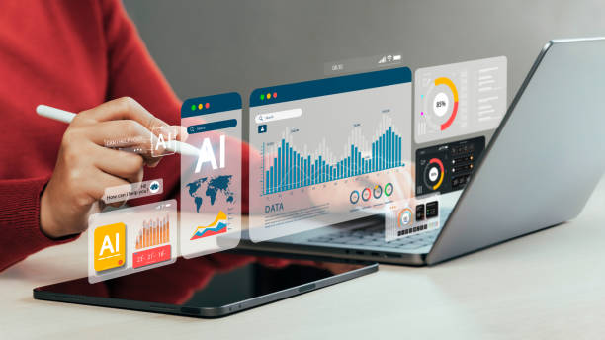***AI in Digital Marketing: The Future of Intelligent Marketing:***

Have you ever experienced how online advertisements seem to know precisely what you’re looking for? It feels almost magical when you search for a product once and then start encountering relevant ads everywhere. However, this isn’t sorcery—it’s AI transforming the landscape of [digital marketing](https://vaishalig.online/). From tailored recommendations to AI-driven chatbots, artificial intelligence is reshaping the way businesses engage with their customers.

AI has evolved beyond being a mere trend; it is now a vital resource for marketers seeking to improve efficiency, enhance engagement, and execute highly targeted campaigns. But how does AI accomplish this? Let’s explore the realm of AI in digital marketing and see how it’s revolutionizing the industry.

***How AI*** [***is Transforming Digital Marketing***](https://vaishalig.online/ai-for-marketing/)***:***

AI is no longer a concept of the future—it’s a present reality, making digital marketing more effective than ever before. Traditional marketing relied heavily on manual labor, guesswork, and lengthy processes. AI addresses these issues by automating repetitive tasks, analyzing vast amounts of data, and offering insights that empower marketers to make informed decisions based on data.

Rather than spending countless hours deciphering customer desires, AI can forecast behaviors, recommend enhancements, and optimize campaigns in real time. Whether you’re managing social media advertisements, email marketing, or SEO initiatives, AI ensures that you reach the right audience at the right moment with the right message.

***Boosting Personalization and Customer Experience:***

Today’s consumers expect brands to recognize their needs and preferences. AI simplifies the process of personalization. By examining browsing habits, previous purchases, and interaction patterns, AI enables businesses to customize their marketing strategies.

Consider Netflix, which suggests movies and shows based on your viewing history. E-commerce sites operate similarly, recommending products you are most likely to purchase. This degree of personalization enhances customer engagement, fosters brand loyalty, and drives sales.  
  
Amazon utilizes AI-driven algorithms to examine customer behavior and recommend products tailored to their preferences. This approach creates a smooth shopping experience that appears uniquely designed for every individual.  
  
***AI-Driven Chatbots: The Next Era of Customer Support:***

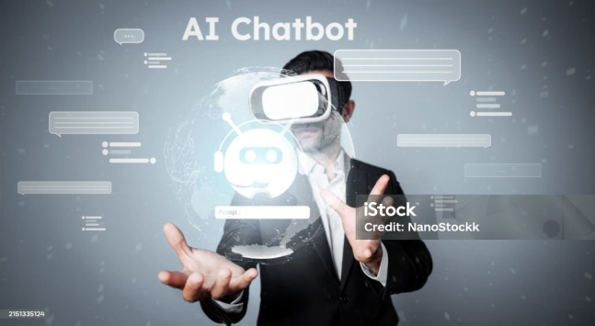The era of waiting on hold for customer service is over. AI chatbots have revolutionized the way businesses connect with their customers. These smart virtual assistants offer immediate assistance, respond to frequently asked questions, and help users navigate their purchasing choices around the clock.

Chatbots such as Drift, ChatGPT, and Intercom can manage numerous conversations at once, delivering real-time solutions. They enhance the customer experience, shorten response times, and allow human agents to focus on more intricate inquiries. Additionally, these chatbots continuously learn, refining their responses and increasing their efficiency over time.

Companies that implement AI Chatbots have reported higher customer satisfaction and lower operational costs. By providing instant attention to customers, they foster better engagement and boost conversion rates.

***Enhanced Content Creation and Optimization:***

Content marketing remains central to digital marketing, and AI is elevating it further. Marketers no longer have to invest hours in brainstorming blog ideas or crafting ad copy from scratch. AI-powered tools can produce high-quality content in just minutes.

Examples of effective AI-driven content creation tools include Jasper AI, Copy.ai, and Writesonic. These platforms assist marketers in effortlessly creating captivating blog posts, social media captions, email campaigns, and product descriptions.

AI also plays a crucial role in SEO. Tools like Surfer SEO and Clearscope examine search trends, recommend optimal keywords, and enhance content for improved rankings. This ensures that content reaches the appropriate audience at the right moment, driving increased organic traffic.

***AI in Social Media Marketing:***

[Social media](https://vaishalig.online/smm/) platforms generate enormous amounts of data daily. AI assists marketers in interpreting this data, monitoring engagement, and forecasting trends.

Tools like Hootsuite, Sprout Social, and Lately AI leverage AI to analyze audience behavior, schedule posts at the most effective times, and provide insights into the types of content that perform best. AI-enhanced social media advertisements can adjust targeting in real-time, maximizing return on investment.  
  
For example, Facebook and Instagram ads use [AI algorithms](https://www.geeksforgeeks.org/ai-algorithms/) to determine which users are most likely to engage with an Ad. This increases conversions and lowers ad costs by eliminating wasted impressions.  
  
***AI-Enhanced Email Marketing Automation:***

[Email marketing](https://vaishalig.online/email-marketing/) continues to be one of the most powerful digital marketing tactics, and the integration of AI has significantly enhanced its effectiveness. AI-driven email automation tools customize content, refine subject lines, and identify the optimal times to send emails, maximizing audience engagement.

Services like Mailchimp, HubSpot, and Marketo assess subscriber behavior to develop personalized email campaigns. AI forecasts which content will appeal to various audience segments, boosting open rates and conversion rates.

Rather than dispatching generic emails, AI guarantees that each subscriber receives content tailored to their interests. This approach fosters greater engagement, strengthens customer relationships, and drives revenue growth.

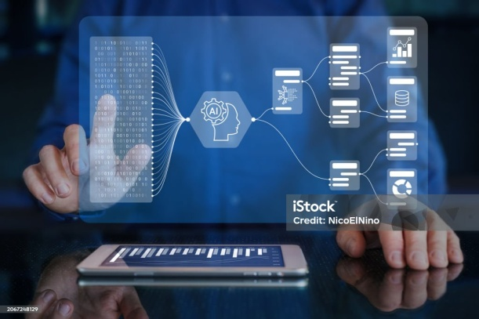***Predictive Analytics: Enhancing Marketing Strategies:***

AI-enabled predictive analytics empowers marketers to anticipate trends, understand customer behavior, and evaluate campaign effectiveness. By leveraging data rather than intuition, businesses can make informed decisions that mitigate risks and enhance ROI.

Tools like Google Analytics, IBM Watson, and Salesforce Einstein utilize AI to scrutinize historical data and deliver actionable insights. Marketers can identify successful strategies, pinpoint areas for improvement, and determine the most effective next steps.

Additionally, predictive analytics aids businesses in recognizing potential leads and devising the best strategies to convert them into paying customers, acting as a guiding force for your marketing efforts.

***Essential AI Tools for*** [***Digital Marketers***](https://vaishalig.online/)***:***

AI is pervasive in digital marketing, and to maintain a competitive edge, the following tools are essential:

* **ChatGPT** – An AI-driven chatbot for customer support and content creation.
* **Jasper AI** – Facilitates the rapid generation of high-quality marketing content.
* **Copy.ai** – Aids in crafting compelling ad copy and blog articles.
* **Hootsuite** – Employs AI to analyze social media trends and engagement metrics.
* **Mailchimp** – Streamlines and personalizes email marketing initiatives.
* **Google Analytics** – Offers AI-powered insights for informed decision-making.
* **Surfer SEO** – Enhances content for search engine optimization.
* **Drift** – AI-powered chatbot for lead generation and customer support.

These tools help marketers save time, reduce costs, and improve campaign effectiveness. Whether you’re a small business owner or a marketing expert, AI can take your strategy to the next level.  
  
***The Future of AI in Digital Marketing:***

AI is advancing at a remarkable pace, and its influence in marketing is set to grow significantly. We can anticipate increasingly sophisticated automation, highly personalized experiences, and enhanced decision-making capabilities. Companies that adopt this technology will find themselves with a distinct advantage as AI continues to evolve.

Envision AI-driven virtual assistants orchestrating entire marketing strategies, AI-crafted videos customized for individual users, and real-time adjustments to advertisements based on user engagement. The potential is limitless.

***Conclusion:***

AI is not merely changing digital marketing; it is fundamentally altering the way businesses connect with their customers. From Chatbots and predictive analytics to content creation and customized marketing, AI is enhancing the efficiency and effectiveness of marketing efforts.

To remain competitive in the digital landscape, incorporating AI into your marketing strategy is essential, not optional. The future of marketing is upon us, and AI is at the forefront!

Are you prepared to harness AI and boost your digital marketing efforts? Now is the perfect moment to utilize AI-driven tools and outpace your competitors!